System Requirement Specification For

IMMACULE LIFE SCIENCES PVT. LTD.

Name | : | Material Tracking System
Location | : | BCIL – Mumbai
Department | : | Software
Document ID | : | BCIL_MUM_2022_P0011-Immacule_Life Sciences–Material Tracking System-SRS
No. of pages | :
Issue Date | :
Effective Date | :

ANNOUNCEMENT
This document contains information, which is the proprietary property of Bar Code India Limited. This document is received in confidence and its contents cannot be disclosed or copied without the prior written consent of Bar Code India Limited. Nothing in this document constitutes a guaranty, warranty, or license, express or implied. Bar Code India Limited disclaims all liability for all such guaranties, warranties, and licenses, including but not limited to: Fitness for a particular purpose; merchantability; not infringement of intellectual property or other rights of any third party or of Bar Code India Limited; indemnity; and all others. The reader is advised that third parties can have intellectual property rights that can be relevant to this document and the technologies discussed herein, and are advised to seek the advice of competent legal counsel, without obligation of Bar Code India Limited. Bar Code India Limited retains the right to make changes to this document at any time, without notice. Bar Code India Limited makes no warranty for the use of this document and assumes no responsibility for any errors that can appear in the document nor does it make a commitment to update the information contained herein.

COPYRIGHT
Copyright © BCI 2022. All rights reserved.

TRADEMARKS
* Other product and corporate names may be trademarks of other companies and are used only for explanation and to the owners' benefit, without intent to infringe.

DOCUMENT APPROVAL

 | Name | Sign | Date
Author
Reviewer
Approver

DOCUMENT HISTORY

Version / Release | Change Description | Revision Date | Approved By
1.1 / 1.1 | Revised Document | 31.5.2022 | Ritu Kapoor

TABLE OF CONTENTS
- Purpose 6
- Scope 6
  - In- Scope 6
- Overview of System 6
- Hardware Requirements 7
- Software Requirements 7
- System Architecture 7
- Application Modules 8
  - Login 8
  - Change Password 9
- Master 10
  - User Master 10
  - Plant Master 12
  - Bin Master 14
  - Booth Master 16
  - Printer Master 18
8.4 Weighing Master 20
- Raw Material Transactions 22
  - RM Barcode (SU) Label Printing 22
  - Sampling 25
  - QC Status (Approve / Reject) 30
  - Material Allocation 31
  - Picking 33
  - Dispensing 36
  - Production Verification 41
  - Material Return (MRN) 43
  - RM (SU) Material Status Display 45
- FG Transactions 46
  - FG Barcode Label Printing 46
  - FG Material Allocation 50
  - Generate FG Picklist 52
  - FG Dispatch 54

Purpose
The purpose of this document is to explain the system architecture of Material Tracking system throughout the life cycle of the project. This document communicates the justification of software process & application module specification in detailed manner to understand the brief of it. BCIL is pleased to submit this document to understand the application solution on customer requirement.

Scope
The scope of this system is describing Material Tracking System for The Immacule Life Sciences.

In- Scope
This document targets primarily the developers, projects managers and document writers. Secondary audience would if possibly include testers who have previous knowledge of software design or databases, but they are mostly recommended to just read the introduction and features specified in this document. The rest of this document contains information on the overall description of the application product, the system features and any other requirements needed that do not fall into these categories.

The screen prototypes have been used while designing samples screens in this document may vary in actual development.

Overview of System
The Material Tracking System implements the persistent data requirement for producing material movement activities across Store to Production and Packaging to FG Inward / Outward of a IMMACULE LIFE SCIENCES for tracking movement through bar-coding. The solution is designed to satisfy the business rules while maintaining data integrity, consistency & performance. All the modules of Material Tracking system are described in following section; information is presented with detailed descriptions to understand & support operational needs.

The entire solution consists of followings:
- Web Based Client Application [Microsoft.Net]
- HHT (Hand Held Terminal) based – Middleware Application [Android]

Hardware Requirements
- Windows 2012Server with Intel Xeon E5-26902.60 GHz, 32GB RAM, 1TB HDD
- MS SQL Server 2008 or above standard /Enterprise Edition.
- 2 GBPS or higher speed redundant LAN Card.
- HHT (Hand Held Terminals)
- PC

Software Requirements
Software Name | Dot Net Framework 4.0 or later
Database | SQL Server 2008R2 or later
Installer | Microsoft Windows Intsaller, Crystal Report 10 or later (if required)
Other Requirements | Separate User ID should be created with administrative rights assigned to install & configure Barcode Track and Trace system on server & User PCs.

System Architecture
‘
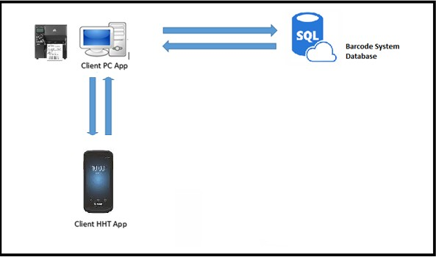

Application Modules

Login
Business Process Identification

Module | This module will be developed to login into the application.
Description | This module will be used to login into the application. In this module, user will have to  enter his User Name, Password. Once User Name, Password get validated in the application, then user will be able to access other modules of the application.
Proposed Process

Sr. No | Topics
1. | Proposed Process Explanation
Following is the snapshot of the login module which will be used to login into application.
Sample Screen

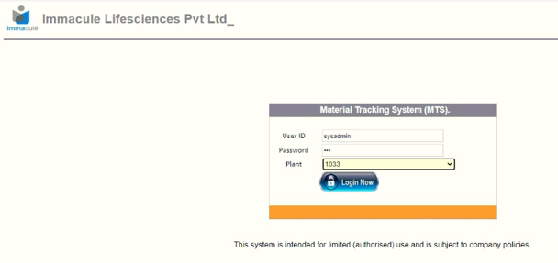
In this module, User has to enter his User Name, Password. After entering this, he has to click on the Login button.
For Forgot Password :
In case of user forgot the password, and then user has to contact to system administrator to reset the password.

Change Password
Business Process Identification

Module | This module will be developed to change password.
Description | This module will be used to change password for login into the application. In this module, user will have to old Password, New Password and confirm password (same new password). Once User Name, old Password gets validated in the application and  changes it.

Proposed Process

Sr. No | Topics
1. | Proposed Process Explanation
Following is the snapshot of the login module which will be used to change password into application.
Sample Screen

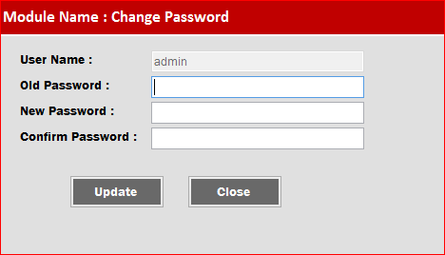
In this module, User has to enter old Password, New password and Confirm Password (same as New Password). After entering this, he has to click on the “Update” button.

Master

User Master
Business Process Identification

Module | This module will be created to maintain the Users.
Description | This master will maintain details of all the users who will be using this application. This master will be connected to the database and user details maintained in database. In addition, This master will have module access privileges captured against each user  and assigned by administrator.

Proposed Process

Sr. No | Topics
1. | Proposed Process Explanation
Following is the snapshot of the User master module which will be used to create or maintain user details in application.
Sample Screen

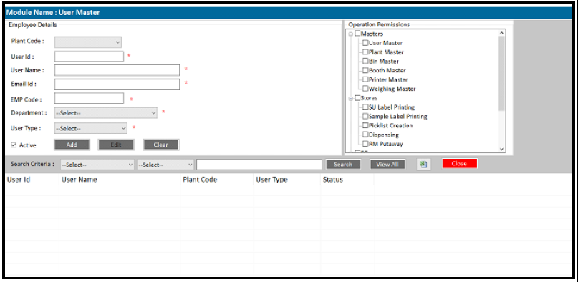

Following steps has to be followed to operate this master. Create New User Entry:
- Click on the “Add” button. This will enable all the entry fields to enter details.
- User has to enter details in the appropriate fields.
- Then, the User has to click on the “Save” button.
- Application will transact and display the appropriate message of success or failure

on the screen.
Edit Existing User Details:
- User has to find and select the user details by clicking on record number for which he wanted to change the details.
- After selecting record, all the details will get filled in appropriate entry field for editing.
- User has to click on the “Edit” button, this will enable all the entry fields and make them available for changing details.
- Application will enable all the fields except “User id” as user id is the primary and unique value for application.
- After editing all details user has to click on “Save” button.
- Application will transact and display the appropriate message of success or failure on the screen.
Search User details:
- Select searching field i.e. User id, user name, Plant code etc.
- Select searching criteria i.e. equal to, not equal to, Contains etc.
- Enter searching value for selected searching field.
- Click on “Search” button. View all Users details:
- To view all the user details, user can simply click on “View All” button, Software will display list of the user records with details recorded.
Export User Details :
- To Export all user data into excel user can click on ‘Excel’ icon and system will export all the data into Excel / CSV.

Integration Approach
Sr. No | RFC / BAPI
1 | NA

Plant Master
Business Process Identification

Module | Plant Master
Description | This master will be developed to maintain Plant details.
Proposed Process

Sr. No | Topics
1. | Proposed Process Explanation
Following is the snapshot of the Plant master module which will be used to create or maintain Plant details in application.
Sample Screen

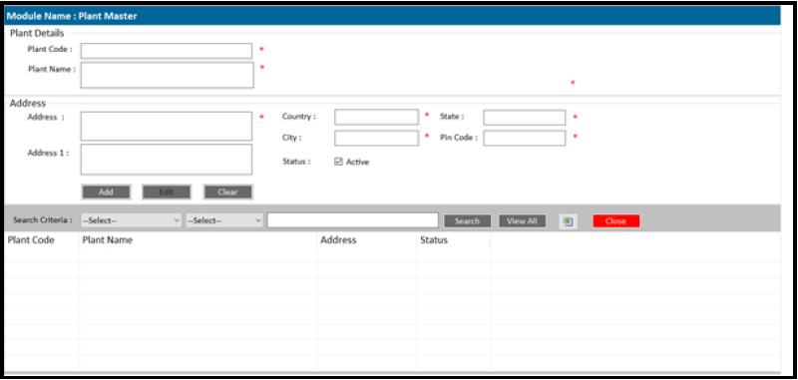

Following steps has to be followed to operate this master. Create New Plant Entry:
- Click on the “Add” button. This will enable all the entry fields to enter details.
- User has to enter details in the appropriate fields.
- Then, the User has to click on the “Save” button.
- Application will transact and display the appropriate message of success or failure on the screen.
Edit Existing Plant Details:
- User has to find and select the plant details by clicking on record number for which he wanted to change the details.
- After selecting record, all the details will get filled in appropriate entry field for editing.

- User has to click on the “Edit” button, this will enable all the entry fields and make them available for changing details.
- Application will enable all the fields except “Plant id” as Plant id is the primary and unique value for application.
- After editing all details user has to click on “Save” button.
- Application will transact and display the appropriate message of success or failure on the screen.
Search Plant details:
- Select searching field i.e. Plant id, Plant name etc.
- Select searching criteria i.e. equal to, not equal to, Contains etc.
- Enter searching value for selected searching field.
- Click on “Search” button. View all Plant details:
- To view all the plant details, user can simply click on “View All” button, Software will display list of the plant records with details recorded.
Export Plant Details :
- To Export all plant data into excel user can click on ‘Excel’ icon and system will export all the data into Excel / CSV.
Integration Approach
Sr. No
1 | NA

Bin Master
Business Process Identification

Module | Bin Master
Description | This master will be developed to maintain Bin details.
Proposed Process

Sr. No | Topics
1. | Proposed Process Explanation
Following is the snapshot of the Bin master module which will be used to create or maintain Bin details in application.
Sample Screen

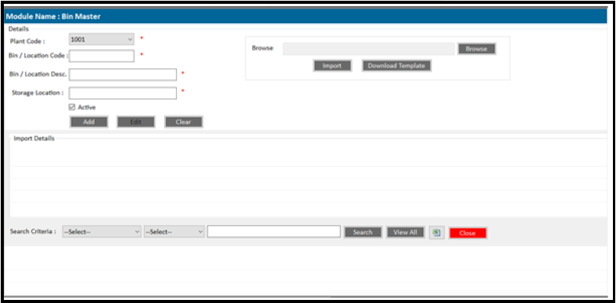

Following steps has to be followed to operate this master. Create New Bin Entry:
- Click on the “Add” button. This will enable all the entry fields to enter details.
- User has to enter details in the appropriate fields.
- Then, the User has to click on the “Save” button.
- Application will transact and display the appropriate message of success or failure on the screen.
Edit Existing Bin Details:
- User has to find and select the Bin details by clicking on record number for which he wanted to change the details.

- After selecting record, all the details will get filled in appropriate entry field for editing.
- User has to click on the “Edit” button, this will enable all the entry fields and make them available for changing details.
- Application will enable all the fields except “Bin id” as Bin id is the primary and unique value for application.
- After editing all details user has to click on “Save” button.
- Application will transact and display the appropriate message of success or failure on the screen.
Search Location details:
- Select searching field i.e. Location Code, Location name, Plant ID etc.
- Select searching criteria i.e. equal to, not equal to, Contains etc.
- Enter searching value for selected searching field.
- Click on “Search” button. Import Data :
- User can import bins data from Excel directly.
- User has to download a template by clicking ‘Download Template’ button.
- User has to fill the data into template and save into PC.
- User has to select the saved file by clicking ‘Browse’ Button and then has to click the import button to import the bin data from excel file.
View all Plant details:
- To view all the plant details, user can simply click on “View All” button, Software will display list of the bins/locations records with details recorded.
Integration Approach
Sr. No
1 | NA

Booth Master
Business Process Identification

Module | Booth Master
Description | This master will be developed to maintain Booth details.
Proposed Process

Sr. No | Topics
1. | Proposed Process Explanation
Following is the snapshot of the Booth master module which will be used to create or maintain Booths details in application.
Sample Screen

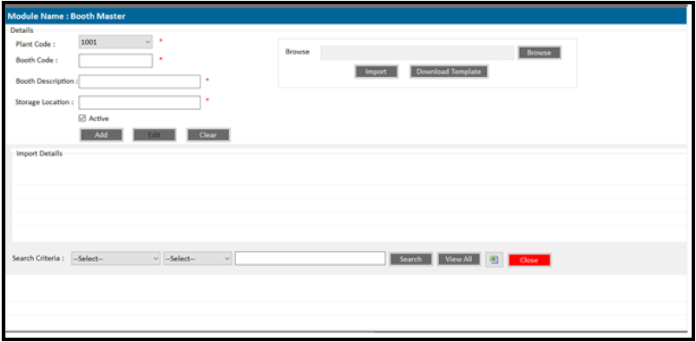

Following steps has to be followed to operate this master. Create New Booth Entry:
- Click on the “Add” button. This will enable all the entry fields to enter details.
- User has to enter details in the appropriate fields.
- Then, the User has to click on the “Save” button.
- Application will transact and display the appropriate message of success or failure on the screen.
Edit Existing Booth Details:
- User has to find and select the Booth details by clicking on record number for which he wanted to change the details.
- After selecting record, all the details will get filled in appropriate entry field for editing.

- User has to click on the “Edit” button, this will enable all the entry fields and make them available for changing details.
- Application will enable all the fields except “Booth id” as Booth id is the primary and unique value for application.
- After editing all details user has to click on “Save” button.
- Application will transact and display the appropriate message of success or failure on the screen.
Search Booth details:
- Select searching field i.e. Booth Code, Booth name, Plant ID etc.
- Select searching criteria i.e. equal to, not equal to, Contains etc.
- Enter searching value for selected searching field.
- Click on “Search” button. Import Data :
- User can import Booth data from Excel directly.
- User has to download a template by clicking ‘Download Template’ button.
- User has to fill the data into template and save into PC.
- User has to select the saved file by clicking ‘Browse’ Button and then has to click the import button to import the Booth data from excel file.
View all Plant details:
- To view all the Booth details, user can simply click on “View All” button, Software will display list of the plant records with details recorded.
Integration Approach
Sr. No
1 | NA

Printer Master
Business Process Identification

Module | Printer Master
Description | This master will be developed to maintain Printer details.
Proposed Process

Sr. No | Topics
1. | Proposed Process Explanation
Following is the snapshot of the Printer master module which will be used to create or maintain Printer details in application.
Sample Screen

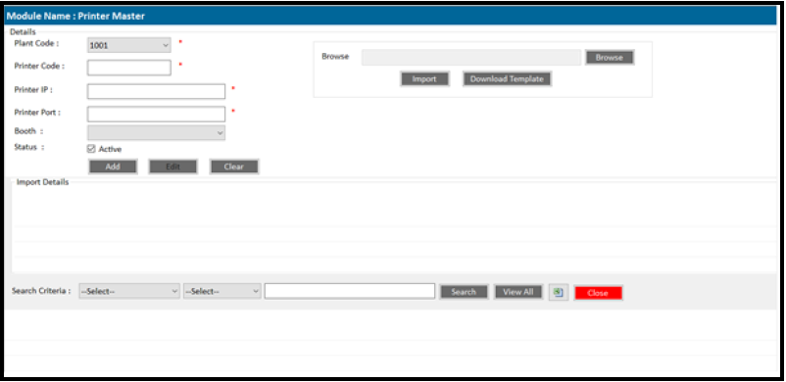

Following steps has to be followed to operate this master. Create New Printer Entry:
- Click on the “Add” button. This will enable all the entry fields to enter details.
- User has to enter details in the appropriate fields.
- Then, the User has to click on the “Save” button.
- Application will transact and display the appropriate message of success or failure on the screen.
Edit Existing Printer Details:
- User has to find and select the Printer details by clicking on record number for which he wanted to change the details.
- After selecting record, all the details will get filled in appropriate entry field for editing.

- User has to click on the “Edit” button, this will enable all the entry fields and make them available for changing details.
- Application will enable all the fields except “Printer id” as Printer id is the primary and unique value for application.
- After editing all details user has to click on “Save” button.
- Application will transact and display the appropriate message of success or failure on the screen.
Search Printer details:
- Select searching field i.e. Printer Code, Booth ID, Plant ID etc.
- Select searching criteria i.e. equal to, not equal to, Contains etc.
- Enter searching value for selected searching field.
- Click on “Search” button. Import Data :
- User can import Printer data from Excel directly.
- User has to download a template by clicking ‘Download Template’ button.
- User has to fill the data into template and save into PC.
- User has to select the saved file by clicking ‘Browse’ Button and then has to click the import button to import the Printer data from excel file.
View all Plant details:
- To view all the Printer details, user can simply click on “View All” button, Software will display list of the plant records with details recorded.
Integration Approach
Sr. No
1 | NA

8.4 Weighing Master
Business Process Identification

Module | Printer Master
Description | This master will be developed to maintain Weighing details.
Proposed Process

Sr. No | Topics
1. | Proposed Process Explanation
Following is the snapshot of the Weighing master module which will be used to create or maintain Weighing details in application.
Sample Screen

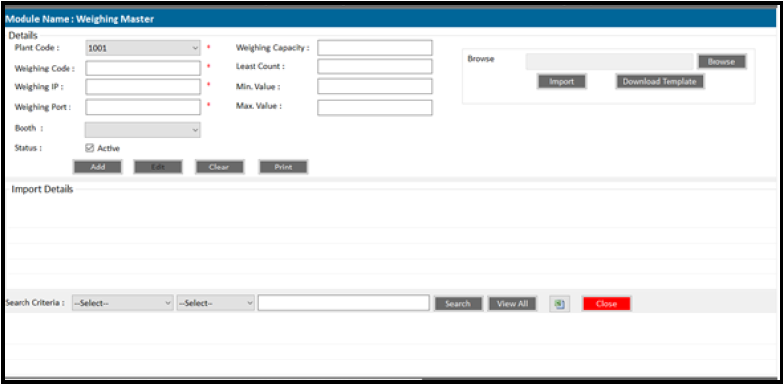

Following steps has to be followed to operate this master. Create New Weighing Entry:
- Click on the “Add” button. This will enable all the entry fields to enter details.
- User has to enter details in the appropriate fields.
- Then, the User has to click on the “Save” button.
- Application will transact and display the appropriate message of success or failure on the screen.
Edit Existing Weighing Details:
- User has to find and select the Weighing details by clicking on record number for which he wanted to change the details.
- After selecting record, all the details will get filled in appropriate entry field for editing.

- User has to click on the “Edit” button, this will enable all the entry fields and make them available for changing details.
- Application will enable all the fields except “Weighing id” as Weighing id is the primary and unique value for application.
- After editing all details user has to click on “Save” button.
- Application will transact and display the appropriate message of success or failure on the screen.
Print Weighing Barcode Label:
- User has to find and select the Weighing details by selecting on record number and then has to click the ‘Print’ button.
- System will generate the barcode label with there IDs.

Search Weighing details:
- Select searching field i.e. Weighing ID, Booth ID, and Plant ID etc.
- Select searching criteria i.e. equal to, not equal to, Contains etc.
- Enter searching value for selected searching field.
- Click on “Search” button. Import Data :
- User can import Weighing data from Excel directly.
- User has to download a template by clicking ‘Download Template’ button.
- User has to fill the data into template and save into PC.
- User has to select the saved file by clicking ‘Browse’ Button and then has to click the import button to import the Weighing data from excel file.
View all Plant details:
- To view all the Printer details, user can simply click on “View All” button, Software will display list of the plant records with details recorded.
Integration Approach
Sr. No
1 | NA

Raw Material Transactions

RM Barcode (SU) Label Printing

Business Process Identification

Module | RM Barcode (Single ) Label Printing
Description | This module will used to fetch the GRN details and to print the RM barcode labels
Proposed Process

Sr. No | Topics
1. | Proposed Process Explanation
Following is the snapshot of the Barcode Label Printing module which will be used to fetch the GRN details and to print barcode labels.
Sample Screen

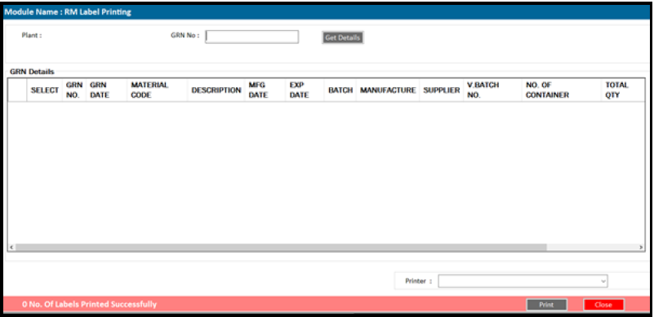

Get GRN Details :
- User will create the GRN in the ERP.
- After creating the GRN in ERP, user will login into Barcode Application and has to access RM label Printing Screen from main menu.
- User has to enter the GRN no. and click on ‘Get Details’
- System will fetch data from ERP and display the GRN details into list box.
Print RM Labels :
- User has to select one or multiple line item from the list box.
- User has to select printer from drop down list and has to click on ‘Print’ button.

- System will print the RM (SU) label as per the no. of container mansions in the GRN.
- Once the printing is done, then system will not allow user to print the labels with same GRN No.
Re-Print RM Labels :
Sample Screen
Following is the snapshot of the RM barcode label Re-Printing.

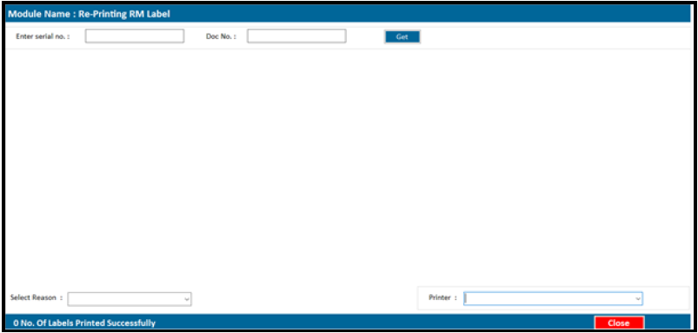

- To Reprint RM barcode label, user has to log-in into the BCIL application and has to access the Re-Print RM label from main menu.
- User has to enter the GRN / Barcode serial no. and has to press the ‘GET’ button
- System will display the barcode serial no. data into the list box.
- User has to select the Reason of Reprinting from the drop down list.

Integration Approach
Sr. No | RFC / BAPI
1 | ERP should send following data to Barcode application  - GRN No.  - GRN Item No.  - GRN Date  - Material Code  - Material Name  - Batch No.  - MFG Date  - EXP Date  - No. Of Container  - Total Qty.

- Base UOM
- Container UOM
- Supplier Name
- Manufacture Name
- Vendor Batch no.
- Storage Condition

Label Format
Sr. No
1 | 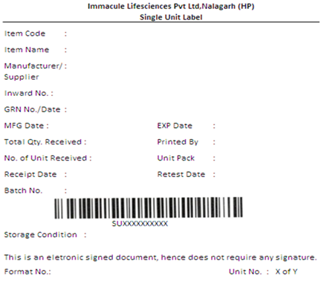  Label Size : 4 x 4

Sampling

Business Process Identification

Module | Sampling
Description | This module will used to print sample label and apply the sample label against the RM  label
Proposed Process

Sr. No | Topics
1. | Proposed Process Explanation
There are two options to print the sample barcode label printing.

In option 1, user will print the sample label first using barcode desktop printer through the system and then while affixing, user will scan the RM (SU) label and Sample label.

In Option 2, user will first scan the RM (SU) label using device and base on the details user will print the sample label using Mobile Barcode Printer.

Option 1:-
Following is the snapshot of the Sample Barcode Label Printing module which will be used to fetch the AR No. details and to print barcode labels.
Sample Screen

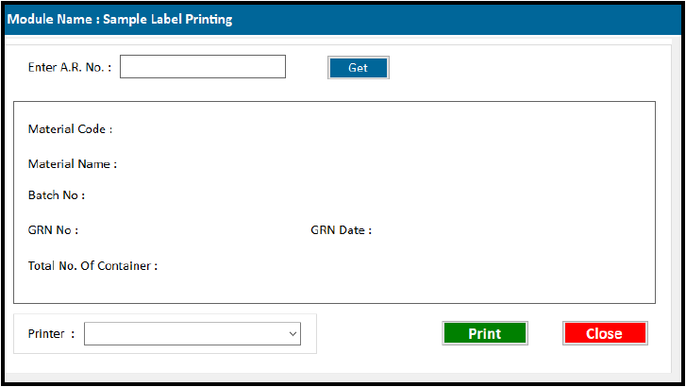

Get A.R. No Details :
- After creating the GRN the A.R. No. is generated in ERP and ERP will send the AR No. details to BCIL.
- To Print the Sample label labels user has to login into BCIL application and access the Sample barcode printing screen.
- Then user has to enter the AR no. and has to click ‘Get’ button.
- System will display the AR no. details on the screen and the number of container to print sample labels base on the information comes from ERP.
Print Sample Labels :
- To print the sample labels, user has to select the printer from drop down list and then has to click on the ‘Print’ button to print the sample label.
- System will generate the unique no. of sampled label.

Affixing Sample Label to Container :
Following is the snapshot of the device application screen to validate the RM (SU) Label against the Sample label while affixing on the container.
Sample Screen

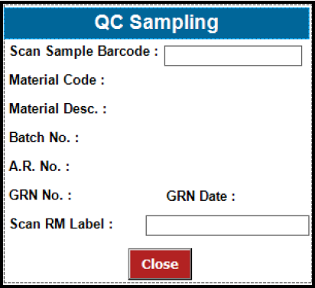

- To access this screen, user has to log in into barcode device application and has to access the QC Sampling Screen.
- In this screen user has to scan the sample barcode label and system will display

the details of the sampled barcode i.e. Material code, Name, Batch No., A.R. No., GRN No. and Date.
        - Then user has to scan the RM (SU) barcode label, and system will validate the RM barcode details and sample barcode details.
        - If the all the details matches then system will update the status of the container as sampled otherwise alert message will display to the user.
        - Also system will alert the user is same barcode label will scan twice.

Option 2:-
In this option user will print the sample barcode at real time while sampling by scanning the RM (SU) barcode label.

Sample Screen
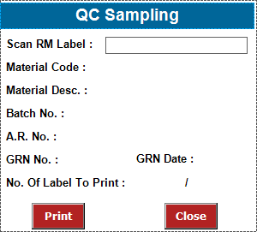
        - To access this screen user has to login into device application and access the QC sampling (Printing) Screen.
        - Before printing sample label in real time, user has to carry the mobile barcode printer.
        - User has to scan the RM Barcode label and system will validate the barcode no. and display the detail of the Material on the device screen.
        - Base on the details system also display the no. of containers to be sampled.
        - User has to click on the ‘Print’ button and system will print the sample label on mobile barcode printer and the system will update sampling status against the scanned container.

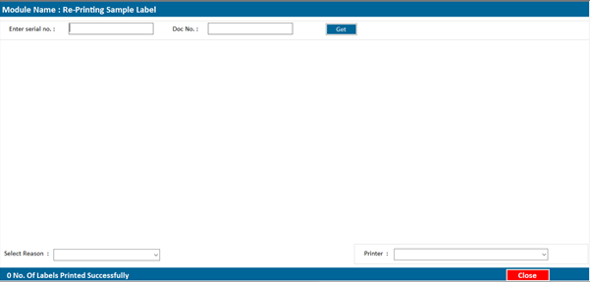
Re-test Sample label Printing:
When material goes into re-test then ERP will send the re-test details with new A.R. No. against the old A.R. No. to the barcode application.

User has to use the same procedure which is used for Sampling label printing (i.e. Option 1 / Option 2) with new AR No and system will print the new sampling label against the Re-test A.R. No.

Re-Print Sample Labels :
Sample Screen
Following is the snapshot of the Sample barcode label Re-Printing.

        - To Reprint Sample barcode label, user has to log-in into the BCIL application and has to access the Re-Print RM label from main menu.
        - User has to enter the AR No / Barcode serial no. and has to press the ‘GET’ button
        - System will display the barcode serial no. data into the list box.
        - User has to select the Reason of Reprinting from the drop down list.
        - User has to click on ‘Print’ Button to re-print the sample label.

Integration Approach

Sr. No | RFC / BAPI
1 | ERP should send QC details against the GRN No. GRN no.  GRN Date Material Code Batch No.  A.R. No.  QC Status.

Label Format
Sr. No
1 | 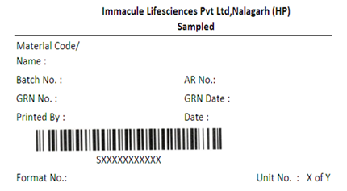  Label Size : 3 x 2

QC Status (Approve / Reject)

Business Process Identification

Module | QC Status
Description | This module will used to update the QC status.
Proposed Process

Sr. No | Topics
1. | Proposed Process Explanation
The QC status i.e. after UD done in LIMS / ERP then the ERP will send the QC status to barcode application.
For this process, there will be barcode scheduler which runs on the server and fetch the
QC status from ERP on hourly basis against the A.R. No.

Integration Approach
Sr. No | RFC / BAPI
1 | ERP should send QC Status against the GRN No. GRN no.  GRN Date Material Code Batch No.  A.R. No.  QC Status.

Material Allocation

Business Process Identification

Module | Material allocation
Description | This module used to map the container with the rack / bin.
Proposed Process

Sr. No | Topics
1. | Proposed Process Explanation
Following is the snapshot of the Material allocation module which is used map the container barcode (RM barcode) to the Bin.
Sample Screen

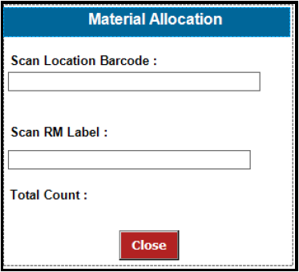

- For the material allocation, user has to login into device application and access to material allocation screen.
- User has scanned the location barcode and system will validate the scanned location with the location master.
- Then user has to scan the RM (SU) label barcode and system will validate the RM (SU) label with the database.
- If the all detail is correct then the system will update the location against scanned container else system will give alert message on the device.
- Once the allocation completed system will update the stock into the system.

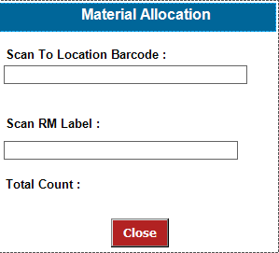
Location to Location Transfer :
Following screen is used to transfer container from one location to another.
Sample Screen
- For the Location transfer, user has to login into device application and access to location transfer screen.
- User has scanned the location barcode where user want to transfer the material and system will validate the scanned location with the location master.
- Then user has to scan the RM (SU) label barcode and system will validate the RM (SU) label with the database.
- If the all detail is correct then the system will update the new location against scanned container else system will give alert message on the device.
- Once the allocation completed system will update the stock into the system.

Integration Approach
Sr. No | RFC / BAPI
 | NA

Picking

Business Process Identification

Module | Picking
Description | This module used to pick the material for dispensing.
Proposed Process

Sr. No | Topics
1. | Proposed Process Explanation
Picklist Generation :
Following is the snapshot of the Picklist generation module which is used create pick list against single or multiple batches.
Sample Screen

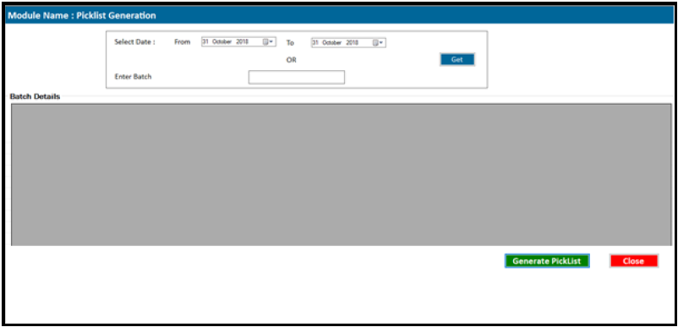

- To generate the picklist, user has to login into PC application and access the generate picklist.
- Here user gets two options, to generate picklist i.e. either for single batch or by multiple batch.
- User has to select the date range or to enter batch no. and then has to click ‘Get’ button.
- System will display all the batch details into the list box.
- Then user has to click on ‘Generate Picklist’ button to generate picklist.
- System will generate a picklist in the PDF format with a unique picklist no.
- After creating the picklist system will lock those location which are in the generated picklist.

Picking :
Following screen is used to pick the material from the location.
Sample Screen

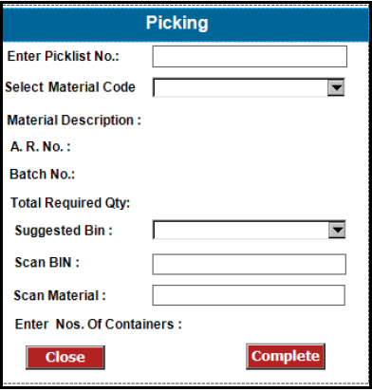

- For picking process, user has to login into device application and has to access the picking screen.
- User has to enter the picklist no and has to press the enter button.
- System will display all the material into drop down list against the picklist no.
- User will select the material code from the drop down list and the system will display the
A.R. No, Batch No. and total quantity required for picking.
- System will display the suggest bin / location in drop down list for the selected material.
- Then user has to scan the location barcode and system will validate location with the suggested location.
- In case of wrong location scanned, system will alert the user with the message on the device screen.
- Then user has to scan the RM (SU) label of the material and system will validate the material with the selected material code, A.R. no, Batch No and the location scanned.
- If all the details matched then system will update the material as picked into the system.

Integration Approach
Sr. No | RFC / BAPI
ERP should send following data to Barcode application
- Batch No.
- Date

- Product Code
- Product Name
- Product Batch
- Material Code
- Material Name
- Batch No.
- A.R. No
- Total Qty.
- UOM

Dispensing

Business Process Identification

Module | Dispensing
Description | This module used to dispense the material to production.
Proposed Process
Sr. No Topics

Proposed Process Explanation
Following is the snapshot of the dispensing module which is used create dispense the material to production.
Sample Screen
Screen 1
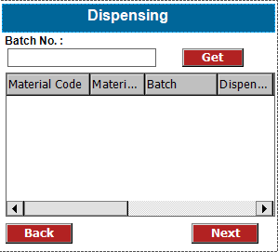
Screen 2

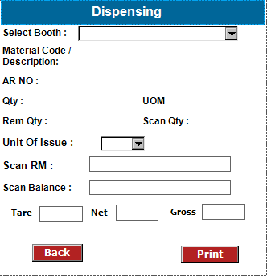

- For dispensing, user has to login into device application and has to access the dispensing screen.
- User has to enter the batch no. and system will display all the material details into the list box.
- Then user has to select the one material from the list for dispensing and then user has to click on ‘Next’ button
- In the next screen (screen 2) system will display the selected material code, material name,
A.R. No, Material Quantity required for dispensing and UOM.
- User has to scan the RM (SU) label of the selected material.
- System will validate the scanned material code, A.R. No against the selected material.
- If the details match with the select material then system will allow user foe weighing activity else system will give alert message to user on screen.
- Then user will scan the weighing balance barcode, and system will validate the weighing barcode with the weighing master.
- System will fetch the weight from the weighing scale and display the tare weight on the device.
- Then user will fill the material into bag / container and again scan the weighing scale and system will fetch the weight and display the gross weight on the screen and the net weight will automatically calculated by the system.
- System will not allow user to take more weight than require for dispensing.
- User has to press ‘Print’ Button after taking the weight and system will generate the dispensing label from barcode printer which is in selected booth.
- After all material weighing are completed, then the system will send the dispensing information to ERP and stock will reduce from the respective material.

Reverse Picking :
Following is the snapshot of the Reverse Picking module which is used to reverse the remaining material after dispensing to stock.
Sample Screen

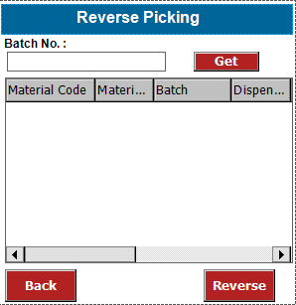
- For ‘Reversal Picking’ user has to login into device application and access the reverse picking screen.
- User will enter the batch and has to click on the ‘GET’ button.
- System will fetch batch data and display only those material details which are not used completely.
- User has to select the material from the list box then user has to click on the ‘Reverse’ button to reverse the selected material.
- System will update the stock of selected material in the system.
- After that user can move the material to location by using ‘Location to Location’ transfer module.

Dispensing Confirmation :
Following is the snapshot of the Order Dispensing Confirmation Module which is used to confirm the dispensing of the material.
Sample Screen

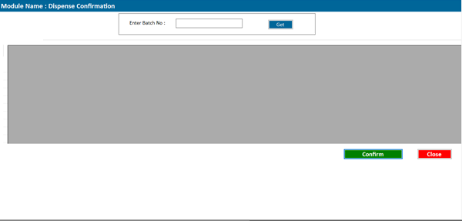
- To confirm dispensing of the material, user has to login to barcode application and access the dispense confirmation screen.
- User will enter the batch no. and has to click on GET button.
- System will fetch the details of dispensing against the batch.
- Then user has to click on Confirm button to confirm dispatch and the stock will reduce from the system.
- While confirmation system also validate each material quantity and then allow user to confirm.

Re-Print Dispensing Labels :
Sample Screen
Following is the snapshot of the Dispensing barcode label Re-Printing.

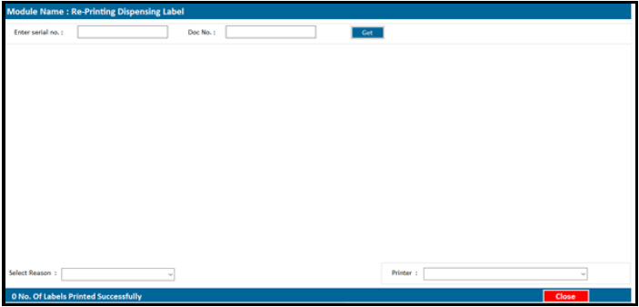
- To Reprint Dispensing barcode label, user has to log-in into the BCIL application and has to access the Re-Print RM label from main menu.
- User has to enter the GRN / Barcode serial no. and has to press the ‘GET’ button

- System will display the barcode serial no. data into the list box.
- User has to select the Reason of Reprinting from the drop down list.
- User has to click on ‘Print’ Button to re-print the sample label.

Integration Approach
Sr. No | RFC / BAPI
Barcode application will send following data to ERP
- Batch No.
- Date
- Product Code
- Product Name
- Product Batch
- Material Code
- Material Name
- Batch No.
- A.R. No
- Total Qty.
- UOM
Label Format
Sr. No
1 | 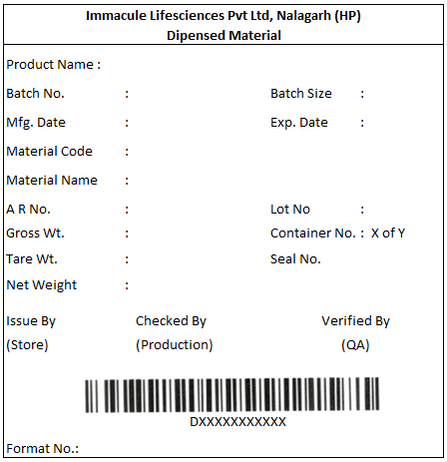  Label Size : 4 x 4

Production Verification

Business Process Identification

Module | Production Verification
Description | This module used to verify the dispensed material before move for production.
Proposed Process

Sr. No | Topics
1. | Proposed Process Explanation
Following is the snapshot of the production verification module which is used for verification of dispensed material by production person before production.

Sample Screen

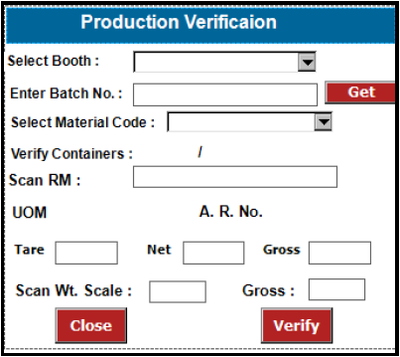

- For production verification, user has to login into device application and access the production verification screen.
- User will select the booth from dropdown list and then user has to enter the batch no.
- Then user has to click on ‘GET’ button and system will validate the batch no. and display the dispensed material list into dropdown list.
- User has to select the material from dropdown list and system will display the total no. of container dispensed of the selected material.
- Then user has to scan the dispensed barcode label.
- System will validate the scanned dispensed barcode label and display the A. R. No, and Tare, Net, and Gross wt with UOM.
- User has to scan the weighing balance barcode to get the gross wt. of the scanned

container.
- If the weight of dispensed container and the weight capture is matched considering the tolerance then system will mark the container as verified else system will give alert message to user on device.
- Once all the dispensed material are verified successfully then system will generate the Production verification done label for selected batch.

Integration Approach
Sr. No | RFC / BAPI
 | NA

Material Return (MRN)

Business Process Identification

Module | Material Return
Description | This module used to print the material return label to return the material from  Production to Store.
Proposed Process

Sr. No | Topics
1. | Proposed Process Explanation
Following is the snapshot of the MRN barcode label printing module to generate the MRN label in the production.
Sample Screen

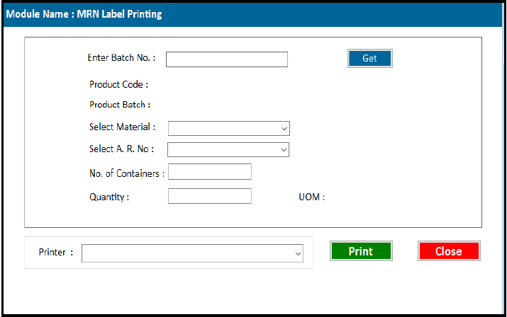

- To generate the MRN label user has to login into barcode application and access the MRN label printing screen.
- User will enter the batch no. and click on the Get button.
- System will validate the batch and display the product code and product batch and the list of the material into dropdown list.
- Then user has to select the A. R. no. into the dropdown list.
- Then user has to enter the no. of container and the quantity per container.
- Then user has to select the printer and then has to click on ‘Print’ Button.

- System will print the unique MRN barcode label from barcode printer.

MRN Label Verification
Following is the snapshot of the MRN barcode label verification by store person before taking material into store.
Sample Screen

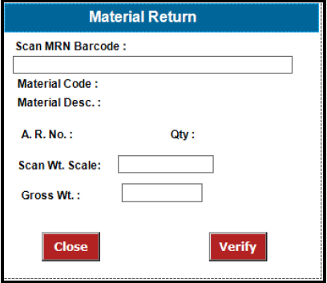

After the printing of MRN label from production department the material send to store.
At the time of receiving store user will verify the material by scanning the MRN label and weight of container.
User has to login into device application and access the Material Return screen.
User will scan the MRN label and system will validate the MRN label and display the material code , description , A. R. No, and the quantity with UOM.
Then user will scan the weighing balance and system will capture the weight of the container and if the weight of the container is match then user has to press the ‘Verify’ button.
System will update the status of MRN label into the system and stock will updated into system

Integration Approach
Sr. No | RFC / BAPI
Barcode application will send following data to ERP Material Code
A.R. No. Quantity UOM

RM (SU) Material Status Display

Business Process Identification

Module | Material Status Display
Description | This module used to view the Material Status.
Proposed Process

Sr. No | Topics
1. | Proposed Process Explanation
Following is the snapshot of the Material Status View module which is used View the current status of the Material
Sample Screen

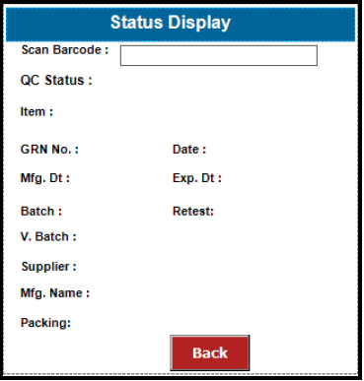

- To view the current material status, user has to login into application and access the Status Display Screen.
- User has to scan the RM (SU) Label and system will display all the details of the scanned container.

Integration Approach
Sr. No | RFC / BAPI
 | NA

FG Transactions

FG Barcode Label Printing

Business Process Identification

Module | FG Barcode Label Printing
Description | This module will used to generate FG barcode label
Proposed Process

Sr. No | Topics
1. | Proposed Process Explanation
Following is the snapshot of the FG Barcode Label Printing module which will be used to fetch the Batch details and to print FG barcode labels.
Sample Screen

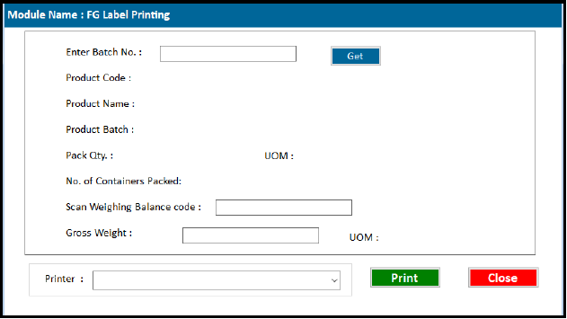
To print the FG barcode label, user has to login into barcode application and has to access the FG Label Printing.
User will enter the FG batch no. and press the “GET” button.
System will fetch the batch details from ERP and display the details on the screen.
User has then scanned the weighing barcode and system will catch the gross weight of box / shipper.
Once the weight is captured into system, user has to click ‘Print’ button and the unique FG label will
printed from the system.

In this way user has to print all the FG labels for the batch.

Re-Print FG Labels :
Sample Screen
Following is the snapshot of the FG barcode label Re-Printing.

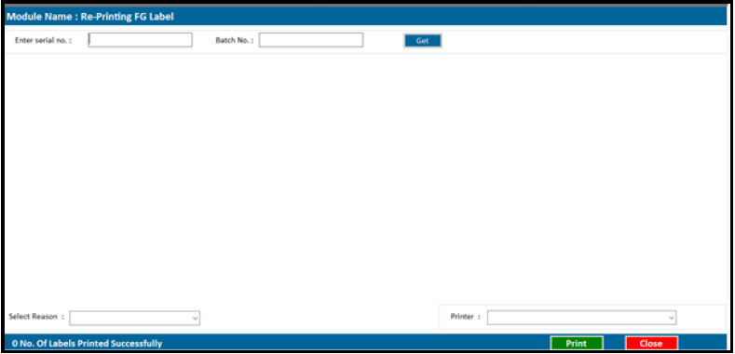
- To Reprint FG barcode label, user has to log-in into the BCIL application and has to access the Re-Print FG label from main menu.
- User has to enter the Batch no. / Barcode serial no. and has to press the ‘GET’ button
- System will display the barcode serial no. data into the list box.
- User has to select the Reason of Reprinting from the drop down list.
- User has to click on ‘Print’ Button to re-print the FG label.
FG Palletization:
Following is the snapshot of the Palletization of FG material which is transfer to the Store
Sample Screen

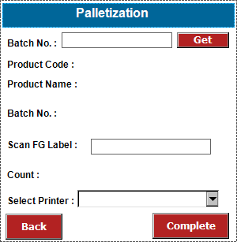
- For FG Palletization, user has to login into device application and access the Palletization screen.
- In this screen user will enter the FG batch no. and click on the GET button.
- System will fetch the data from the system and display the batch details on the device screen.
- Then user has to scan the FG box/ shipper label and system will validate the correct barcode scan against the entered batch no.
- In this way user has to scan each box / shipper and put it on the pallet.
- After completing the activity user has to select the printer and has to press the ‘Complete’ button.
- System will generate a pallet barcode label with product information.

Re-Print Pallet Labels :
Sample Screen
Following is the snapshot of the Pallet barcode label Re-Printing.

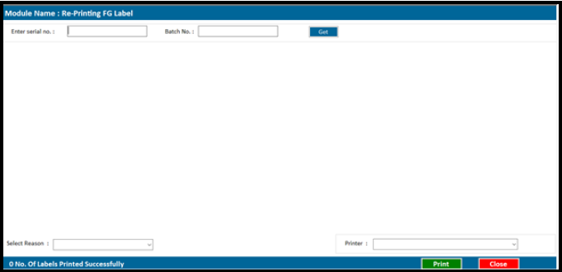
- To Reprint Pallet barcode label, user has to log-in into the BCIL application and has to

access the Re-Print Pallet label from main menu.
- User has to enter the Batch no. / Barcode serial no. and has to press the ‘GET’ button
- System will display the barcode serial no. data into the list box.
- User has to select the Reason of Reprinting from the drop down list.
- User has to click on ‘Print’ Button to re-print the Pallet label.

Integration Approach
Sr. No | RFC / BAPI
 | NA

FG Material Allocation

Business Process Identification

Module | FG Material allocation
Description | This module used to map the FG Pallet with the rack / bin.
Proposed Process

Sr. No | Topics
1. | Proposed Process Explanation
Following is the snapshot of the FG Material allocation module which is used map the container barcode (FG barcode) to the Bin.
Sample Screen

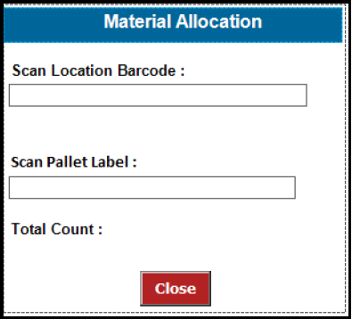

- For the material allocation, user has to login into device application and access to FG material allocation screen.
- User has scanned the location barcode and system will validate the scanned location with the location master.
- Then user has to scan FG Pallet barcode and system will validate the FG Pallet label with the database.
- If the all detail is correct then the system will update the location against scanned pallet else system will give alert message on the device.
- Once the allocation completed system will update the stock into the system.

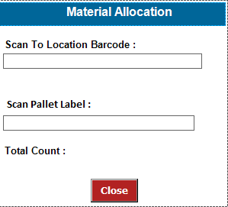
Location to Location Transfer :
Following screen is used to transfer pallet from one location to another.
Sample Screen
- For the Location transfer, user has to login into device application and access to location transfer screen.
- User has scanned the location barcode where user want to transfer the material and system will validate the scanned location with the location master.
- Then user has to scan the RM (SU) label barcode and system will validate the RM (SU) label with the database.
- If the all detail is correct then the system will update the new location against scanned container else system will give alert message on the device.
- Once the allocation completed system will update the stock into the system.

Integration Approach
Sr. No | RFC / BAPI
 | NA

Generate FG Picklist

Business Process Identification

Module | Picklist Generation
Description | This module used to generate the pick list for FG dispatch
Proposed Process

Sr. No | Topics
1. | Proposed Process Explanation
Picklist Generation :
Following is the snapshot of the Picklist generation module which is used create pick list against single or multiple orders.
Sample Screen

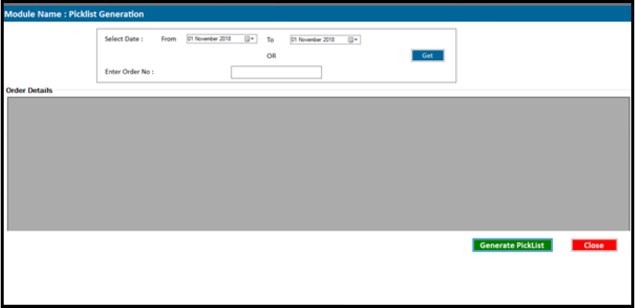

- To generate the picklist, user has to login into PC application and access the generate FG picklist.
- Here user gets two options, to generate picklist i.e. either for single order or by multiple order.
- User has to select the date range or to enter order no. and then has to click ‘Get’ button.
- System will display all the order details into the list box.
- Then user has to click on ‘Generate Picklist’ button to generate picklist.
- System will generate a picklist in the PDF format.

Integration Approach
Sr. No | RFC / BAPI
ERP should send following data to Barcode application
- Order No.
- Order Date
- Product Code
- Product Name
- Product Batch
- Order Quantity

10.3 FG Dispatch

Business Process Identification

Module | FG Dispatch
Description | This module used to for FG Dispatch
Proposed Process
Sr. No Topics

1. Proposed Process Explanation Picklist Generation :
Following is the snapshot of the FG Dispatch module which is used for dispatching FG Material.
Sample Screen
Screen 1
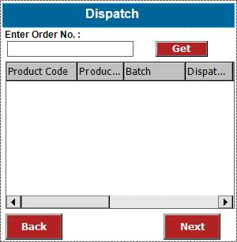
Screen 2
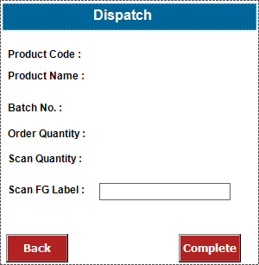

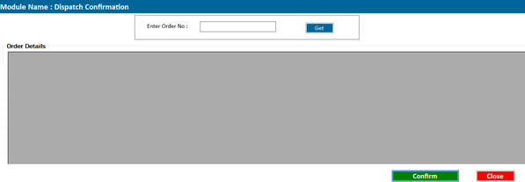
- For dispatching, user has to login into device application and access the Dispatch module.
- In this screen user will to enter the order no. and has to click on GET button.
- System will fetch the order data and display the list of product to dispatch.
- User has to select the Product from the list and has to click Next button.
- In the Next Screen (Screen 2) System will display the selected material details with the order quantity.
- User has to scan FG box / Shipper No. and system will validate the scanned FG code with the selected code and update the dispatch status against the scanned FG barcode label.
- After complete scanning user has click complete button and system will close the dispatch of the selected product in the system.
- In case of wrong / duplicate scanning system will alert message to the user on scanner.

Dispatch Confirmation :
Following is the snapshot of the Order Dispatch Confirmation Module which is used to confirm the dispatch of product.
Sample Screen

- To confirm dispatch, user has to login to barcode application and access the dispatch confirmation screen.
- User will enter the order no. and has to click on GET button.
- System will fetch the details of order with the scanning details.
- Then user has to click on Confirm button to confirm dispatch and the stock will reduce from the system.

Integration Approach
Sr. No | RFC / BAPI
Barcode application will send following data to ERP
- Order No.
- Order Date
- Product Code
- Product Name
- Product Batch
- Order Quantity

